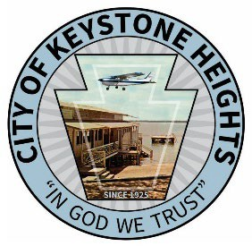
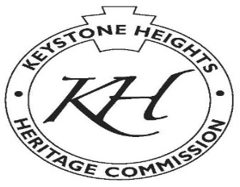
City of Keystone Heights

555 South Lawrence Blvd Keystone Heights, Florida 32656 352.473.4807 Off 352.473.5101 Fax
Heritage Commission Agenda February 20, 2024
10:00 AM

1. Call to Order

• Pledge of Allegiance

2. Approval of Meeting Minutes

• Approval of minutes from January 16, 2024 (not complete)

3. Old Business

• Review of the paddleboard event
• Historic oak designation
• Plaque presentation for Fort 11 and the City of Keystone Heights
• Ordering of Centennial flags for 2025
• Mother’s Day tour of homes planning for Saturday, May 11, 2024
• Workshop for educational field trip planning on April 16, 2024
• Update on historical information tools:
• Large trifold brochures
• Membership cards and application
• Update on walking tour app and Facebook page
• Christmas tour of homes planning for Saturday, December 21, 2024

4. New Business

• Discussion on amphitheater

5. Reports

• Museum proposal
• Yesterdays festival report from Karen Nagel

6. Announcements

7. Public Comments

8. Future Meetings

• Next meeting scheduled for March 19, 2024, at Keystone Heights City Hall

www.keystoneheights.us www.twitter/cityofkeystone www.facebook/keystoneheights

